VASAVI COLLEGE OF ENGINEERING (Autonomous)
IBRAHIMBAGH, HYDERABAD-31
DEPARTMENT OF COMPUTER SCIENCE & ENGINEERING
ASSIGNMENT – II
Subject: Data Mining Branch: B.E 4/4 CSE- B
Academic Year: 2024-25 Semester: VII
DOS: 14.10.2024

SET-I: (1602-21-733-096,102,121,100,084,090,076,073,119,128)

Q.No. | Question | Marks | BTL (1/2/3/4/5/6) | Mapped
 |  |  |  | CO | PO
1. | 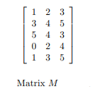  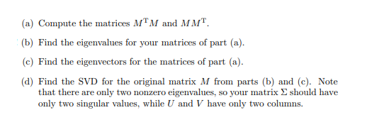 | 1 | 3 | 2 | 1,2
2. | Extraction of valuable data from extensive datasets is a standout amongst the most vital exploration issues. Association rule mining is one of the highly used methods for this purpose. Finding possible associations between items in large transaction based datasets (finding frequent itemsets) is most crucial part of the association rule mining task. Many single-machine based association rule mining algorithms exist but the massive amount of data available these days is above the capacity of a single machine based algorithm. Therefore, to meet the demands of this ever-growing enormous data, there is a need for distributed association rule mining algorithm which can run on multiple machines. For these types of parallel/distributed applications, MapReduce is one of the best fault-tolerant frameworks. Implement a distributed association rule mining algorithm named as Adaptive-Miner which uses adaptive approach for finding frequent patterns with higher accuracy and efficiency. Adaptive-Miner uses an adaptive strategy based on the partial processing of datasets. Adaptive-Miner makes execution plans before every iteration and goes with the best suitable plan to minimize time and space complexity.  https://www.kaggle.com/roshansharma/market-basket-analysis/data | 2 | 3 | 3 | 1,2
3. | Draw a Contingency table for the rule B →D by using the transition database shown below. Use the contingency table and Compute support, confidence and interest factor. | 2 | 3 | 3 | 1,2
  Transaction | Items
  T1 | ACDE
  T2 | BCE
  T3 | ABCE
  F4 | BCDE
  F5 | ABCE
  F6 | ABCD

Set-II: (1602-21-733-068,69,70,71,72,74, 308)

Q.No. | Question | Marks | BTL (1/2/3/4/5/6) | Mapped
 |  |  |  | CO | PO
1. | Represent attributes of the data set as sequences of values ordered along a shared timeline in a single instance in addition to regular single valued attributes, finding temporal associations that represent far more complicated behavior than currently available data mining systems are capable of identifying is made possible. Implement an algorithm that can mine this data in a viable fashion, a tremendous improvement can be had on the volume and quality of knowledge gained. Quantifying the order of complexity of the knowledge represented using these attributes.  https://archive.ics.uci.edu/ml/machine-learning-databases/00352/ | 1 | 3 | 2 | 1,2
2. | Normalize the age attribute values 3,15,16,19,19,20,21,22,25,24,26,29,30,32,33,34,35,35,35,36,40,45,52,70 using Z-Score normalization | 2 | 3 | 2 | 1,2
3. | Find frequent item sets and Strong Association rules using candidate generation for the following dataset by using FP Tree growth Where min_sup=50% Min_Conf=60% | 2 | 3 | 3 | 1,2
  TID | Items
  T100 | I1, I3, I4
  T200 | I2, I3, I5
  T300 | I1, I2, I3, I5
  T400 | I2, I5

Set-III: (1602-21-733-075,77,78, 79,80,81,309)

Q.No. | Question | Marks | BTL (1/2/3/4/5/6) | Mapped
 |  |  |  | CO | PO
1. | Generate concept hierarchy for the given data up to 3 levels You should clearly explain how the partitions are obtained at each level. [If Interval consists of 2 or fewer elements it need not be divided further]  104, 110, 120, 121, 122, 123, 125, 125, 125, 127, 130, 133, 133, 135, 135, 135, 136,  137, 138, 138, 139, 140, 143, 146, 146, 148, 148, 151, 153, 155, 156, 158, 158, 161,  163, 165, 168, 170, 178, 183, 188, 198 | 1 | 3 | 2 | 1,2
2. | Your task for this assignment is to identify and perform an association rule mining task. This involves  - Selecting an appropriate data set  - Preparing and preprocessing the data  - Finding rules, including appropriate parameter setting  - Determining which of the resulting rules are interesting  - Figuring out how the interesting rules could be useful  While you are on your own to select an appropriate data set, I will point you to one easy source: The UCI Machine Learning Repository. | 2 | 3 | 3 | 1,2
3. | a. List all the frequent itemsets if the support count threshold min_sup = 3.  b. What does the anti-monotonicity property of support imply? Give an example using the above data set | 2 | 3 | 3 | 1,2
  C_ID | TID | BasketContent
  1 | T100 | {Aspirin, Panadol}
  1 | T200 | {Aspirin, Sudafed}
  2 | T300 | {Tylenol, Cepacol}
  2 | T400 | {Aspirin, Vitamin C, Sudafed}
  3 | T500 | {Tylenol, Cepacol}
  3 | T600 | {Aspirin, Cepacol}
  4 | T700 | {Aspirin, Vitamin C}
  4 | T800 | {Aspirin, Ibuprofen, Panadol}
  5 | T900 | {Panadol, Vitamin C}
  5 | T1000 | {Tylenol, Cepacol, Ibuprofen}
  6 | T1100 | {Tylenol, Panadol, Cepacol}
  6 | T1200 | {Panadol, Sudafed, Ibuprofen}

Set-IV: (1602-21-733-082,83,86,87,88,89,310)

Q.No. | Question | Marks | BTL (1/2/3/4/5/6) | Mapped
 |  |  |  | CO | PO
1. | 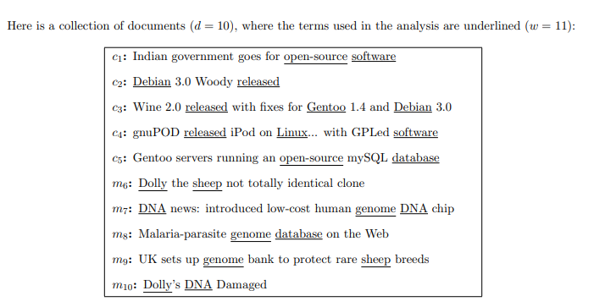  Answer the following questions based on the above data:  1. Transform the data into a term-document matrix A (an 11 × 10 matrix in this case) in the Vector Space Model, where each document vector is normalized to have unit L2-norm.  2. Compute the cosine similarity between each pair of documents, i.e., compute A^{T} A.  3. Compute the Singular Value Decomposition of matrix A. | 1 | 3 | 2 | 1,2
2. | Construct a data cube from Table given below. Is this a dense or sparse data cube? If it is sparse, identify the cells that are empty  Product ID Location ID Number Sold  1 1 10  1 3 6  2 1 5  2 2 22 | 2 | 3 | 2 | 1,2
3. | Find the frequent itemsets for the data given in Table 1 using the Apriori algorithms. Let minsup = 3/6.  Table 1: Transaction database | 2 | 3 | 3 | 1,2
  Transaction | Items
  T1 | ACDE
  T2 | BCE
  T3 | ABCE
  F4 | BCDE
  F5 | ABCE
  F6 | ABCD

Set-V: (1602-21-733-091,92,93,94,95,97,311)

Q.No. | Question | Marks | BTL (1/2/3/4/5/6) | Mapped
 |  |  |  | CO | PO
1. | You are given the Iris dataset at http://www.cs.utexas.edu/~wtang/cs378/iris.tar.gz. The file “iris.data” contains all 150 instances in the Iris dataset. The first four columns of this file correspond to various attributes of the iris plant (sepal length, sepal width, petal length, and petal width). The last column denotes the species type, which is encoded as either 0, 1, or 2 (see the file iris.classes for the mapping from class id to species name). The goal of this problem is visualizing the Iris dataset using Principal Component Analysis (PCA). | 1 | 3 | 2 | 1,2
2. | Suppose that a data warehouse consists of the three dimensions time, doctor, and patient, and the two measures count and charge, where charge is the fee that a doctor charges a patient for a visit.  (a) Enumerate three classes of schemas that are popularly used for modeling data warehouses.  (b) Draw a schema diagram for the above data warehouse using one of the schema classes listed in (a) | 2 | 3 | 2 | 1,2
3. | Find frequent pattern enumeration based on the FP-tree for the dataset given below. Report all the frequent patterns, consider min_sup=2 | 2 | 3 | 3 | 1,2
  C_ID | TID | BasketContent
  1 | T100 | {Aspirin, Panadol}
  1 | T200 | {Aspirin, Sudafed}
  2 | T300 | {Tylenol, Cepacol}
  2 | T400 | {Aspirin, Vitamin C, Sudafed}
  3 | T500 | {Tylenol, Cepacol}
  3 | T600 | {Aspirin, Cepacol}
  4 | T700 | {Aspirin, Vitamin C}
  4 | T800 | {Aspirin, Ibuprofen, Panadol}
  5 | T900 | {Panadol, Vitamin C}
  5 | T1000 | {Tylenol, Cepacol, Ibuprofen}
  6 | T1100 | {Tylenol, Panadol, Cepacol}
  6 | T1200 | {Panadol, Sudafed, Ibuprofen}

Set-VI: (1602-21-733-098,99,101,103,104,105,312)

Q.No. | Question | Marks | BTL (1/2/3/4/5/6) | Mapped
 |  |  |  | CO | PO
1. | Analyze a subset of the Netflix Prize data. This subset contains about 2M ratings, which can be downloaded from http://www.cs.utexas.edu/~wtang/cs378/netflix_subset.tar.gz. You need to complete the following questions to get familiar with the data set:  - Plot a histogram showing the distribution of the number of users for each possible rating.  - Plot the histogram showing no.of ratings for each user | 1 | 3 | 2 | 1,2
2. | A data cube, C, has n dimensions, and each dimension has exactly p distinct values in the base cuboid. Assume that there are no concept hierarchies associated with the dimensions.  (a) What is the maximum number of cells possible in the base cuboid?  (b) What is the minimum number of cells possible in the base cuboid?  (c) What is the maximum number of cells possible (including both base cells and aggregate cells) in the C data cube?  (d) What is the minimum number of cells possible in C? | 2 | 3 | 2 | 1,2
3. | (a) Find all frequent itemsets using FP-growth with min_sup=2  (b) List all the strong association rules with min_confidence=60% | 2 | 3 | 3 | 1,2
  TID | Items bought
  100 | {M,O,N,K,E,Y}
  101 | {D,O,N,K,E,Y}
  102 | {M,A,K,E}
  103 | {M,U,C,K,Y}
  103 | {C,O,O,K,I,E}

Set-VII: (1602-21-733-106,107,108,109,110,111,313)

Q.No. | Question | Marks | BTL (1/2/3/4/5/6) | Mapped
 |  |  |  | CO | PO
1. | Online retail company’s features is an e-wallet service, that holds credit that can be used to pay for products purchased on the platform.  Users can receive credit in three different ways:  - When a product purchase that is paid for is canceled, the money is refunded as cancellation credit.  - Users can receive gift card credit as a gift.  - If a user has a poor service experience, soo-sorry credit may be provided.  Credit in the e-wallet expires after 6 months if it is gift card credit and soo-sorry credit, but in 1 year if it is cancellation credit.  The Finance department of the company would like to build reporting and analytics on the e-wallet service so they can understand the extent of the wallet liabilities the company has.  Some of the questions they would want to answer from this are like below:  - What is the daily balance of credit in the e-wallet service?  - How much credit will expire in the next month?  - What is the outcome (i.e. % used, % expired, % left) of credit given in a particular month?  Design a Data warehouse to answer these questions on e-wallet. | 1 | 3 | 2 | 1,2
2. | Suppose that a data warehouse for Big University consists of the four dimensions student, course, semester, and instructor, and two measures count and avg grade. At the lowest conceptual level (e.g., for a given student, course, semester, and instructor combination), the avg grade measure stores the actual course grade of the student. At higher conceptual levels, avg grade stores the average grade for the given combination.  (a) Draw a snowflake schema diagram for the data warehouse.  (b)Starting with the base cuboid [student,course,semester,instructor], what specific OLAP operations (e.g., roll-up from semester to year) should you perform in order to list the average grade of CS courses for each Big University student. | 2 | 3 | 2 | 1,2
3. | A database has five transactions. Let min sup = 40% and min conf = 60%.  TID Items Bought  T1 {A, C, D}  T2 {B, C, E}  T3 {A, B, C, E}  T4 {B, E}  T5 {E}  (a) Find all frequent itemsets using Apriori and FP-growth, respectively. Please show the pattern generation process. Each process is worth some points. Compare the efficiency of the two mining processes | 2 | 3 | 3 | 1,2

Set-VIII: (1602-21-733-112,113,114,115,116,117,314)

Q.No. | Question | Marks | BTL (1/2/3/4/5/6) | Mapped
 |  |  |  | CO | PO
1. | Reduce the given data using histogram with Equi-width and Equi-frequency histograms  You should partition the data into a bucket of width 10 (write Bucket number: data). Consider 5 buckets for equi-frequency method. Smooth the data by using bin means.  Data 3, 5, 6, 6, 9, 10, 10, 11, 12, 12, 15, 15, 15, 15, 20, 21, 23, 24, 24, 25, 25, 25, 30, 35, 36, 37, 38, 40 | 1 | 3 | 2 | 1,2
2. | Suppose that a data warehouse consists of the four dimensions date, spectator, location, and game, and the two measures count and charge, where charge is the fare that a spectator pays when watching a game on a given date. Spectators may be students, adults, or seniors, with each category having its own charge rate.  (a) Draw a star schema diagram for the data warehouse.  (b) Starting with the base cuboid [date,spectator,location, game], what specific OLAP operations should you perform in order to list the total charge paid by student spectators at GM Place in 2010? | 2 | 3 | 2 | 1,2
3. | The following contingency table summarizes supermarket transaction data, where hot dogs refers to the transactions containing hot dogs, hot dogs refers to the transactions that do not contain hot dogs, hamburgers refers to the transactions containing hamburgers, and hamburgers refers to the transactions that do not contain hamburgers.  Based on the given data, is purchase of hotdogs independent of the purchase of hamburgers? If not, what kind of correlation relationship exists between the two? | 2 | 3 | 3 | 1,2
   | hot dogs | hot dogs | Σ row
  Hamburgers | 2000 | 500 | 2500
  Hamburgers | 1000 | 1500 | 2500
  Σ col | 3000 | 2000 | 5000

Set-IX: (1602-21-733-118,120,122,123,124,125,315)

Q.No. | Question | Marks | BTL (1/2/3/4/5/6) | Mapped
 |  |  |  | CO | PO
1. | Consider the following data. Fill the missing values of the attribute Download speed with mean, median, Linear interpolation and KNN  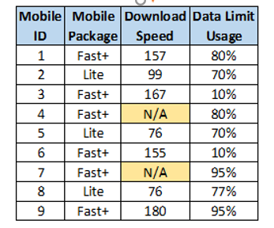 | 1 | 3 | 2 | 1,2
2. | Design a Data warehouse to model student enrollment in University courses. We would like to answer questions such as:  Which courses are most popular?  Which instructors are most popular?  Which courses are most popular among graduate students? Undergraduates?  Are there courses for which the assigned classroom is too large or too small? | 2 | 3 | 2 | 1,2
3. | Draw FP-Tree for the following transactional database and find frequent itemsets with min_sup=2 | 2 | 3 | 3 | 1,2
  Tid | Items
  T100 | {K, A, D, B}
  T200 | {D, A, C, E, B}
  T300 | {C, A, B, E}
  T400 | {B, A, D}

Set-X: (1602-21-733-126,127,129,130,131,132,133,134)
Q.No. | Question | Marks | BTL (1/2/3/4/5/6) | Mapped
 |  |  |  | CO | PO
1. | 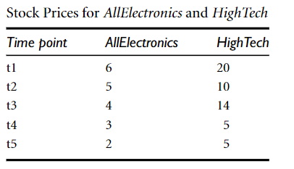  Find the Covariance between the prices at AllElectronics and HighTech outlets | 1 | 3 | 2 | 1,2
2. | Design a data warehouse to find the batting performance by major league baseball players.  There is one fact table (Batting) with the grain of one row per player per game. The dimensions of the Batting fact are Date, Player, Team, Opponent, and GameId. GameId is a degenerate dimension; it holds the unique game identifier assigned by the source system. The Team and Opponent dimensions are two “dimension roles” that reference the same dimension table (Team). Thus, there are threr dimension tables in all (Date, Player, and Team) | 2 | 3 | 2 | 1,2
3. | The minimum support is 60% and the minimum confidence is 80%.  Trans_id Itemlist  T1 {F, A, D, B}  T2 {D, A, C, E, B}  T3 {C, A, B, E}  T4 {B, A, D}  Find the 1, 2 frequent itemsets that satisfy the support criteria | 2 | 3 | 3 | 1,2

***********

